01.10.2018-14.10.2018



**MIDDLE EAST TECHNICAL UNIVERSITY**

DEPARTMENT OF ELECTRICAL AND ELECTRONICS ENGINEERING

EE493 - Weekly Report #1

TROY TECH

**Design Studio Coordinator:** Mustafa Mert ANKARALI (Section 7)

**Partners:**

Hasan ÖZKARA - 2031888

Kağan ÖZASLAN - 2031854

Caner POTUR - 2031250

Mustafa Ercan OKATAN - 2031193

Mert KAYIŞ - 2030997

**Contact Information:**

Hasan Özkara +90 539 454 85 38 hasan.ozkara05@gmail.com

Kağan ÖZASLAN +90 531 293 52 77 knozaslan@gmail.com

Caner POTUR +90 539 587 32 67 canerpotur@gmail.com

Mustafa Ercan OKATAN +90 506 496 15 95 erokatan@gmail.com

Mert KAYIŞ +90 506 841 22 34 mrtkys@gmail.com

**Our Progress in the First Two Weeks**

Starting from the beginning of October 2018, our company members came together based on each individual’s personal traits and skills. We are 5 people including 2 from computer area, 2 from microwaves/antenna area and other from control area. When we heard about the projects were announced, we started to discuss for all. Our members are composed of different areas hence we thought on some projects which requires different knowledges and professions. After that, we looked at all of four projects superficially and did some research to have basic knowledge about general aspects of them. Since we are a kind of multidisciplinary company because of our members are in different areas, we decided that we could tend to choose the project “Devices trying to score in each other’s goals” because it’s related with professions in which we are going to be graduated. But the other projects will definitely be discussed among us, after we will learn all descriptions of the each project.

By the first week, we opened github account as individuals. Also we searched on some logo designs for our company Troy Tech. We are going to most likely decide on one of them. They are shown in Fig. 1.

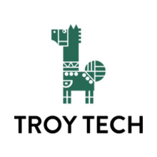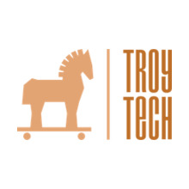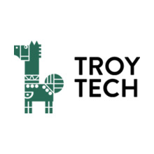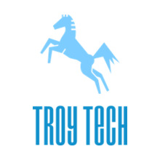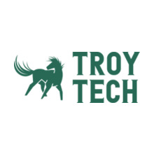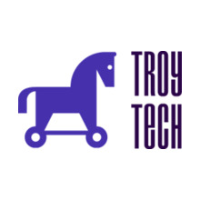

*Figure 1. Some logo examples for our company*

**Plans for Next Week**

We are going to decide on definite logo in the following week. Further details about standards will be discussed after design studio meeting in order to further investigate the difficulties and advantages with respect to our company traits. We are planning to finish our brief researches on the all projects and want to decide what we are going to choose.